Prefix, Postfix Evaluation
- Postfix Evaluation
Rules:
- Start scanning from left to right.
- If the current value is an operand, push it onto the stack.
- If the current is an operator, pop two elements from the stack, apply the at-hand operator on those two popped operands, and push the result onto the stack.
- At the end, pop an element from the stack, and that is the answer.
Example: 4 5 6 * +
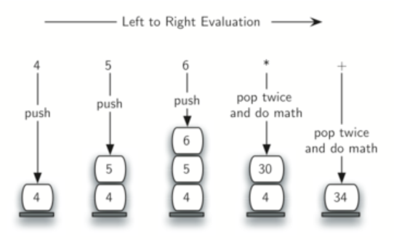
Example: 7 8 + 3 2 + /
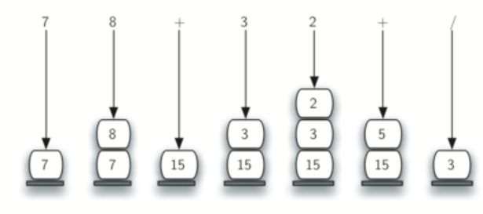
Class activity: Evaluate 2 2 + 3 * 10 -

- Prefix Evaluation
Rules:
- Reverse the given expression.
- Start scanning from left to right.
- If the current value is an operand, push it onto the stack.
- If the current is an operator, pop two elements from the stack, apply the at-hand operator on those two popped operands, and push the result onto the stack.
- At the end, pop an element from the stack, and that is the answer.

Example: - * + 2 2 3 10
